#StayWell2022: A Teen Vaccine QI Learning Collaborative
– Project Participants QIDA At-A-Glance Tool

The following is a basic help sheet to help project participants navigate through the #StayWell2022 Quality Improvement Data Aggregator (QIDA) web-based system.
- System Access
  - To access the system, go to https://qidata.aap.org/StayWell2022. Please note that the system operates best in Firefox or Google Chrome browsers.

- Project Disclosure (first log-in only)
  - When accessing the system for the first time, select Accept to agree to the Project Disclosure.

- System Log-in
  - To log-in to the main project page, use your AAP Login (AAP ID or email address) and password.

- My Profile (first log-in only)
  - When accessing the system for the first time, answer the My Profile questions and select the Submit button at the bottom of the window.

- Project Pages
  - The system contains three project pages, Project Home, Workspace, and My Group. Use the tabs at the top of the screen to toggle between pages.
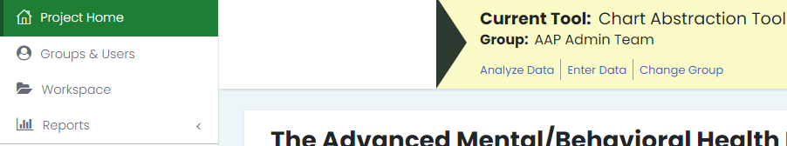
SAMPLE
- Data Entry
  - Each practice team has a designated Data Administrator, who is responsible for entering in practice data. Project participants do not have permissions to enter in practice data.
- Data Analysis
  - Once data has been entered and the cycle is closed, project participants may analyze the data entered for their practice. To access the analyze data section as a participant:
    - Select Analyze Data in the Data Collection Tools section of the Project Home
OR
    - Select the Analyze link from the My Group page

    - From the Analyze Data screen:
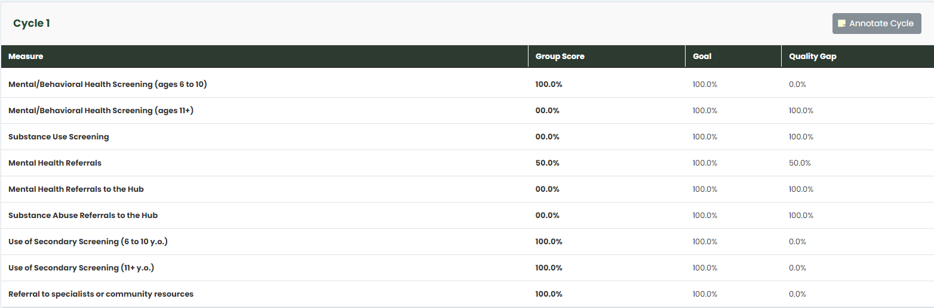
TEST DATA
    - View measure scores in the Measure Analysis section
    - Generate real-time run charts. To generate run charts:
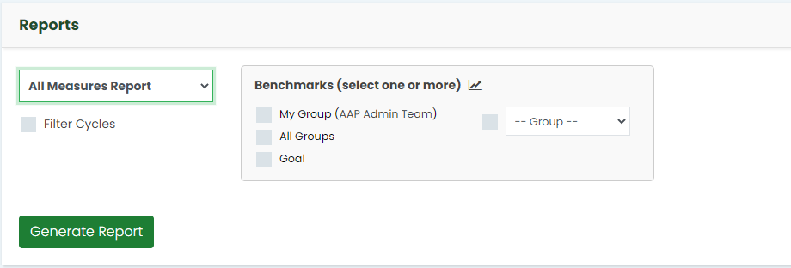
      - Select the Measure from the drop down menu
        - All Measures
        - Individual Measures Report
        - Milestones
        - Raw Data
      - Select Filter Cycles if you are interested in seeing particular cycles instead of all of the cycles
      - Select data tags to add additional data points to the run chart (optional)
      - Select Generate Report
    - Once Generate Report is selected, a run chart will generate and display on the screen.

