TRANSITION to Adult Care

<https://www.gottransition.org/>

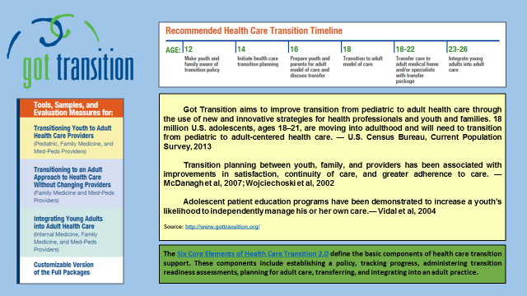

Acknowledgement:

Know Your Health: Empowering Adolescents and Young Adults New Mexico CoIIN Toolkit

<https://docs.google.com/presentation/d/1gmDay0-GhcilF25fgKv_tJUJO8LFEtSj6u-5VQeohbk/edit#slide=id.p4>. Accessed November 1, 2018.