Center Appointments Faculty Data Form Process
- Login to the Faculty Data Form from UAB Forms on AdminSys page.
- Select Faculty Data Form on the left side of the screen.
- Select “Center Appointments” transaction type from FDF dashboard.
- Enter the faculty member’s BlazerID or Employee ID# (Oracle Not Banner).
- Click on “Center Appointment” tab on the left. This opens the fields to add center appointment details.
- Scroll down toward the bottom of the screen, and click on button create center appointment.
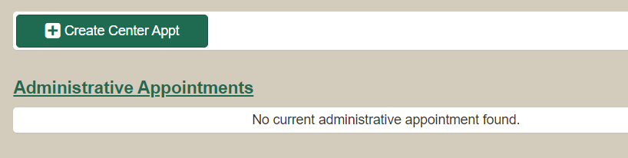
- Complete all fields in the create center appointment section of the FDF.
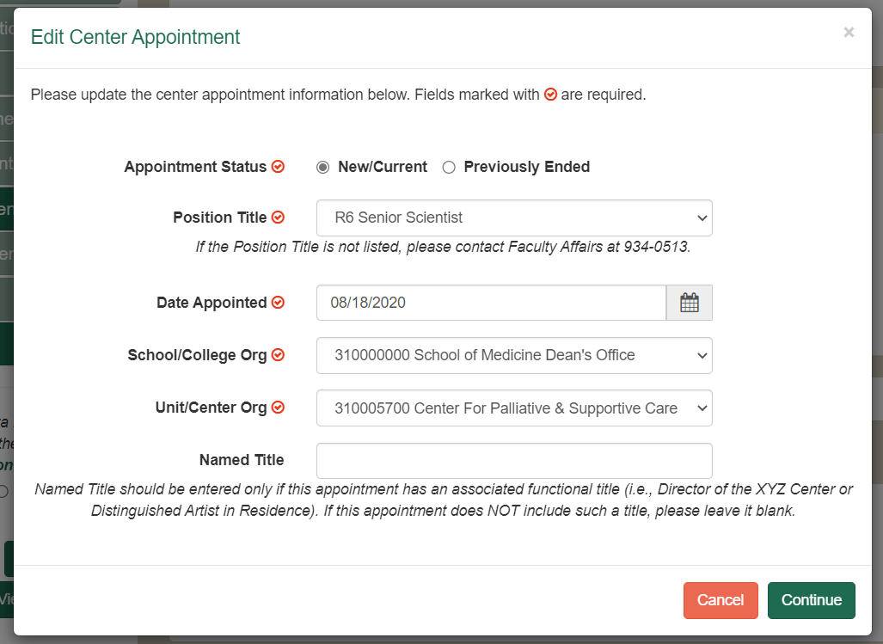
- Click Continue
- The center appointment “RANK” should or is typically equivalent to the faculty member’s rank in their primary faculty appointment.
- The effective date of the appointment must match on both the Center Appointment Letter and the Faculty Data Form.
How to Determine Center Rank/ Title
Present Faculty Rank Center Title
Instructor/Assistant Professor Associate Scientist
Associate Professor Scientist
Professor Senior Scientist
The rank or center title on the FDF MUST match the center appointment title in the appointment letter.
- If the ORG Number for the center has changed (been retired); you must end the previous center appointment. The end date must be one day prior to the effective date of the New Center Appointment.
For Example: 311402010 is the old or retired ORG Number, but 310005700 is the new ORG Number for the Center for Palliative & Supportive Care (UWIRC). If the FDF shows an existing center appointment on 311402010, end that center appointment.
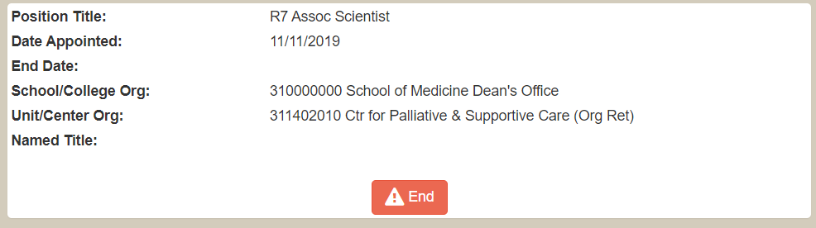
- Click End. This opens the FDF fields for you to enter the end date for the “old” center appointment. Click CONTINUE when you’re done.
Screen shot here….
- Attach appointment letter to the Faculty Data Form (FDF). Click ATTACHMENTS on the left navigation bar (left of the form), and click Add Attachments.
- On the left bottom of the FDF, see the text that says… Is this part of the Faculty Data Correction Initiative? Select YES or NO, and select SAVE if you need to work on the FDF later. Hit SUBMIT if you are ready to submit the FDF into workflow for approval.
- Make sure that the correct center name is included in the appointment letter.
- Center Appointments should be ended on the Faculty Data Form once the faculty member is no longer a member or is affiliated with your center(s).
An example of the details or information that you would enter into the Faculty Data Form when creating a Center Appointment.
Name: Jane Doe
Title: Scientist
Effective Date: 04/23/21
Center Org#: 310005700
Blazer ID: JaneDoe11

