External Clinical Trial Monitor Requests for EHR Access
(Coordinator Instructions)
Below you will find the process for obtaining Cerner IMPACT view-only access for research monitors.
Initial Visit (This process should be initiated at least 30 days prior to the Monitor’s Initial Visit):
- Once a UAB research coordinator is notified of a monitor’s upcoming visit, the coordinator should go to the Health System Information Services portal to enter an account request. https://helpdesk.uabmc.edu/CherwellPortal/Home2?_=743e5bd2#0
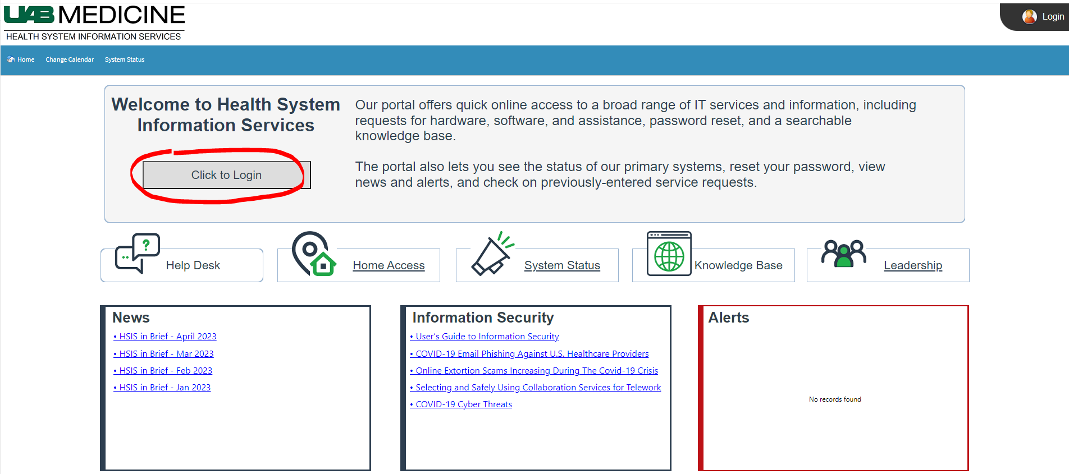
- Click on Account Management
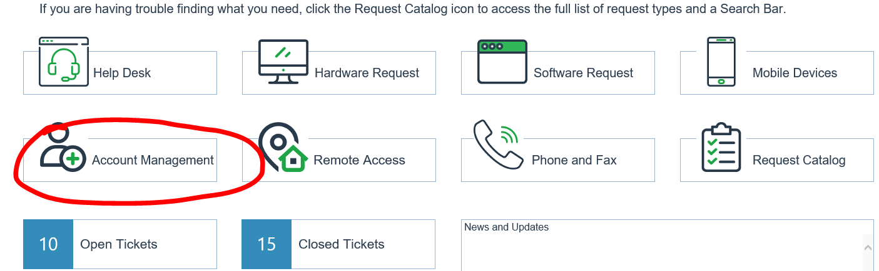

- Choose ‘External Account Request’
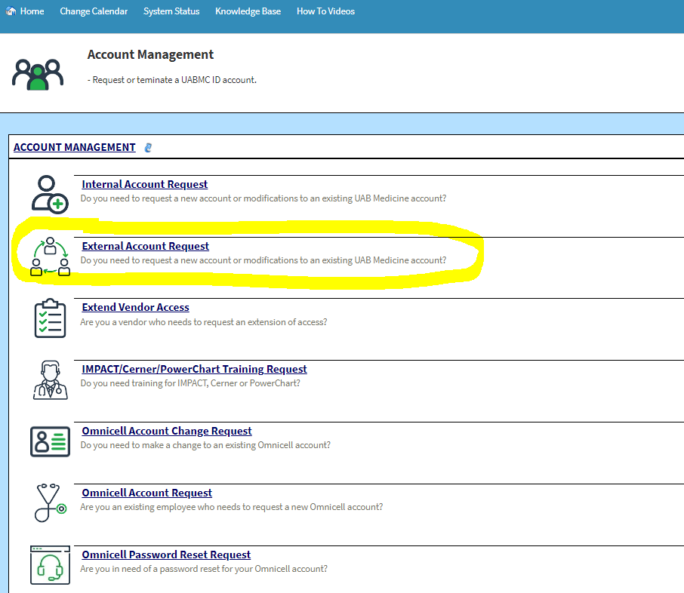

- Complete all fields indicating this is a ‘new account’.
- Indicate the following: The account is for a research monitor, the estimated start date, the purpose of the request is for ‘research’, and how long the account will need to be active.
- Fill in the user’s info and indicate that the accounts needed are ‘AD (Active Directory)’ and ‘Cerner (IMPACT)’. Click ‘Submit’.
  - For the Unique Identifier, one of the following is required in order for an account to be established:
    - Last 6 numeric digits of Social Security Number,
    - Last 6 numeric digits of Driver’s License Number & state, or
    - Last 6 numeric digits of Employee ID
  - This information will be stored encrypted and only used to uniquely identify a user when an account issue arises.

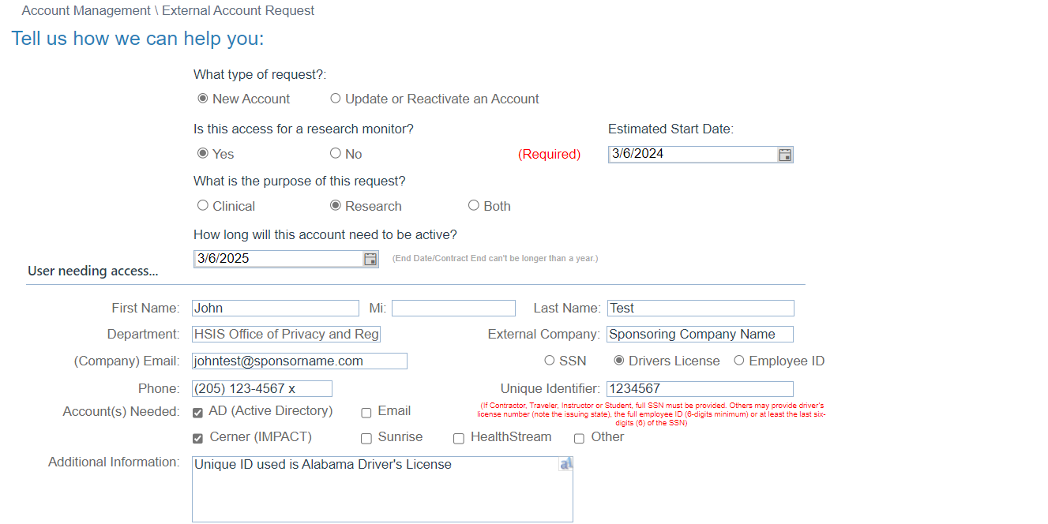

- Once submitted the person entering the information (requestor) will receive a service request (SR) number for tracking purposes.
- Notify the monitor that training must be completed no later than 14 business days prior to the scheduled visit in order to be granted view-only access to Cerner IMPACT.
- The link to the Cerner IMPACT training will be emailed to the monitor at the address provided.
- Once training has been completed, the monitor should reply to the email confirming completion.
  - A new SR will be required should training not be completed within 30 days of the initial request.
- Login information for the monitor will be emailed to the research coordinator (person who enters the request) within 7-10 business days after training completion. The research coordinator is responsible for sharing this information with the monitor.
- After the request has been entered, the UAB research coordinator will need to set up a patient list in Cerner IMPACT using the following steps (the patient list can be built at any time prior to the monitor’s visit):
  - Open IMPACT
  - Click ‘Patient List’ (located in middle top of the page)
  - Click “wrench” symbol
  - Choose ‘New’
  - Choose ‘Custom’
  - Click ‘Next’
  - Add Name of Study in box
  - Click ‘Next’
  - Choose ‘Finish’
Note: When adding patients to the list, highlight the study and click the arrow to move the study to the active list
  - Click ‘Ok’
  - Click “green man” symbol
  - Enter MRN
  - Choose ‘Search’
  - Double click patient’s name
  - When finished adding patient names, click the “wrench” symbol
  - Highlight the study name
  - Click the arrow to move back to the available list
To add a Proxy (Note: this must be completed to grant the monitor access):
- Move the study name to active
NOTE: If additional created lists are present, please take caution to make sure the appropriate active study name is highlighted for the monitor. If another created list is inadvertently highlighted, the monitor will be given view-only access to this list instead.
- Click ‘Properties’ (sign next to the “wrench” symbol)
- Choose ‘Proxy’
- Choose ‘New’ located on the bottom right
- Choose ‘Provider’
- Enter the monitor’s name (Note: Monitor MUST have completed training & be active)
- Choose ‘Access’
- Choose ‘Read-Only’
- For “To” date, enter “2100” for the year
- Choose ‘Ok’. The monitor’s name and access should show-up on the left.

- Notify the monitor that the applicable patient list has been created and will be available to view in IMPACT in a “View-Only” manner at the next visit. Please make the monitor aware that the search function has been disabled in this view and the screen is likely to look different from what was presented in training.

Remote Access
- If the monitor requires remote access to Cerner IMPACT, the Remote Access-Token Request form with the fields indicated as shown below will also need to be completed after the above steps have been completed. Please note that if the research monitor is onsite and using non-UAB equipment, a remote token is still required to access the EMR. The research coordinator should go to the Health System Information Services portal to enter an account request. https://helpdesk.uabmc.edu/CherwellPortal/Home2?_=52266692#2

- Click on the Remote Access icon.
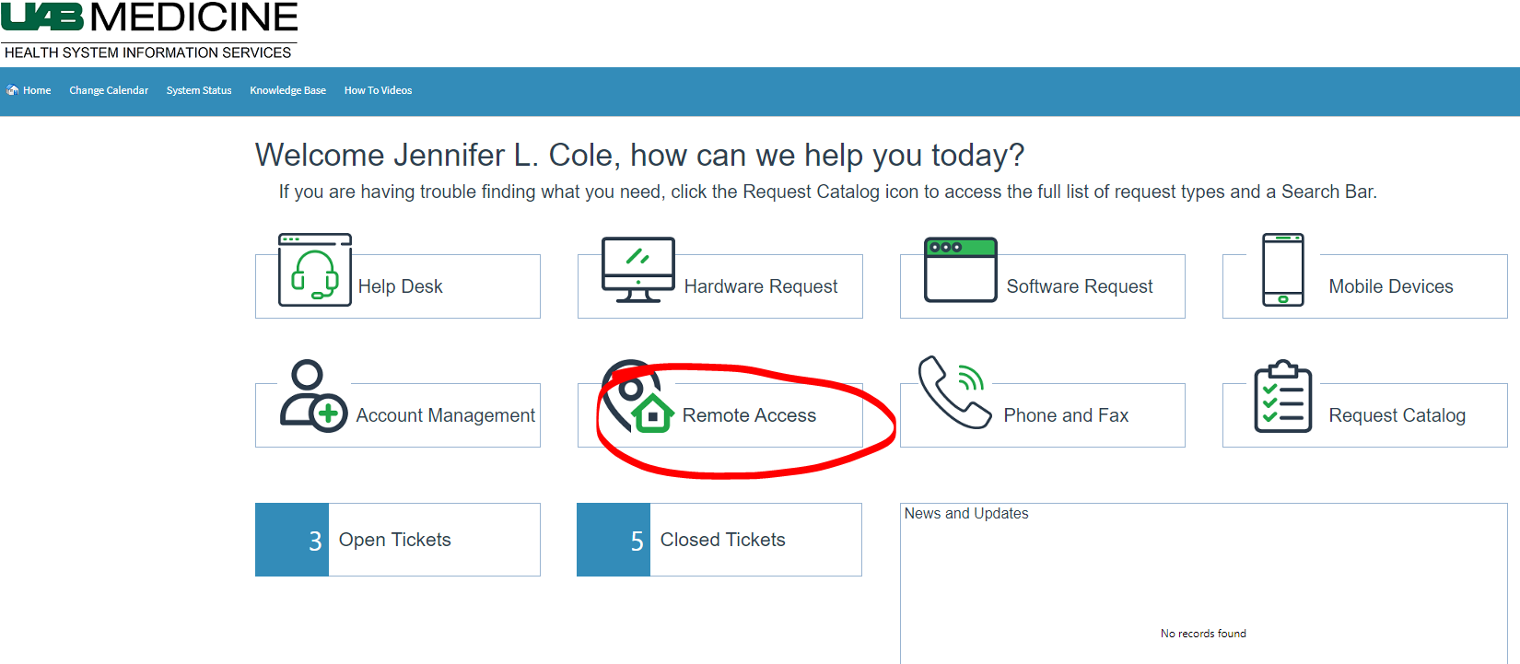
- Choose ‘Token Request’
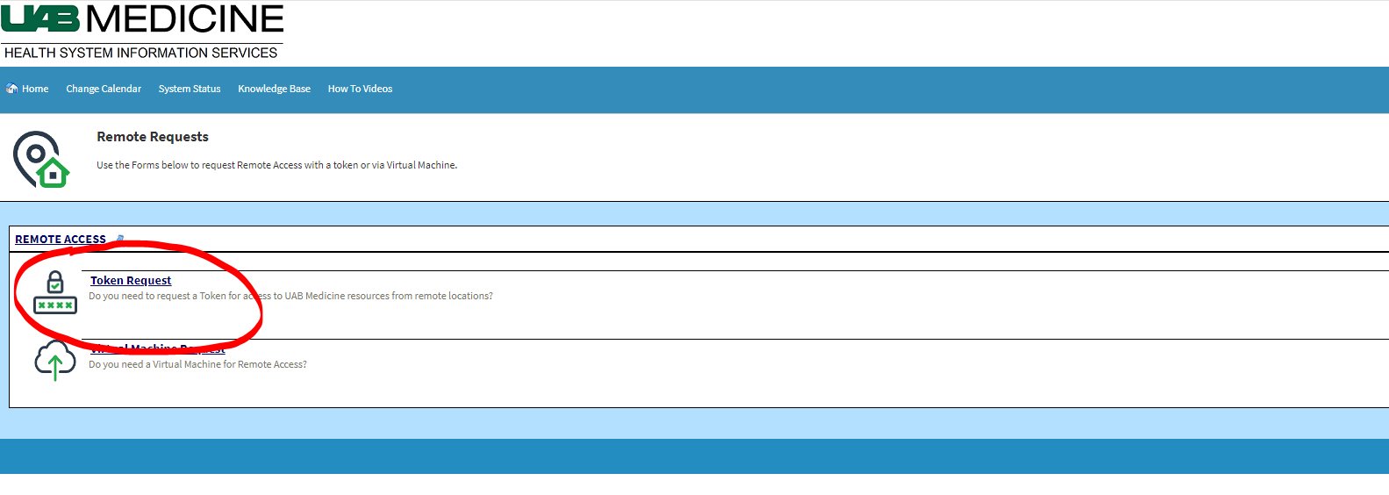

- Complete the form as show below requesting an On Demand Token. Be sure to complete all fields.
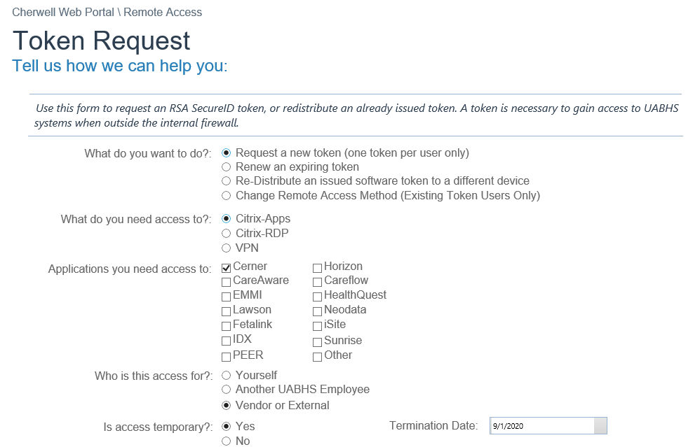
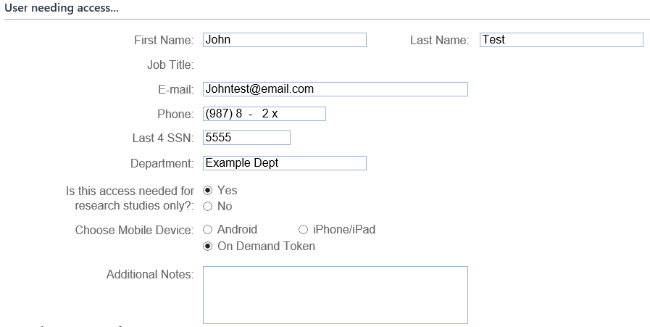
- Once submitted, the requestor will receive a service request (SR) number for tracking purposes.
- Once the token has been created, an email will be sent to the monitor (at the email address provided) from the HSIS Helpdesk (supportdesk@uabmc.edu) with the token activation instructions.

Subsequent Visits/Reactivation of an IMPACT account
- The monitor’s account will be set to expire either annually or on the study expiration date, whichever occurs first. For continued access the research coordinator should go to the Health System Information Services portal to enter an account request. Please allow 7-10 business days for accounts to be reactivated.

https://helpdesk.uabmc.edu/CherwellPortal/Home2?_=52266692#2.

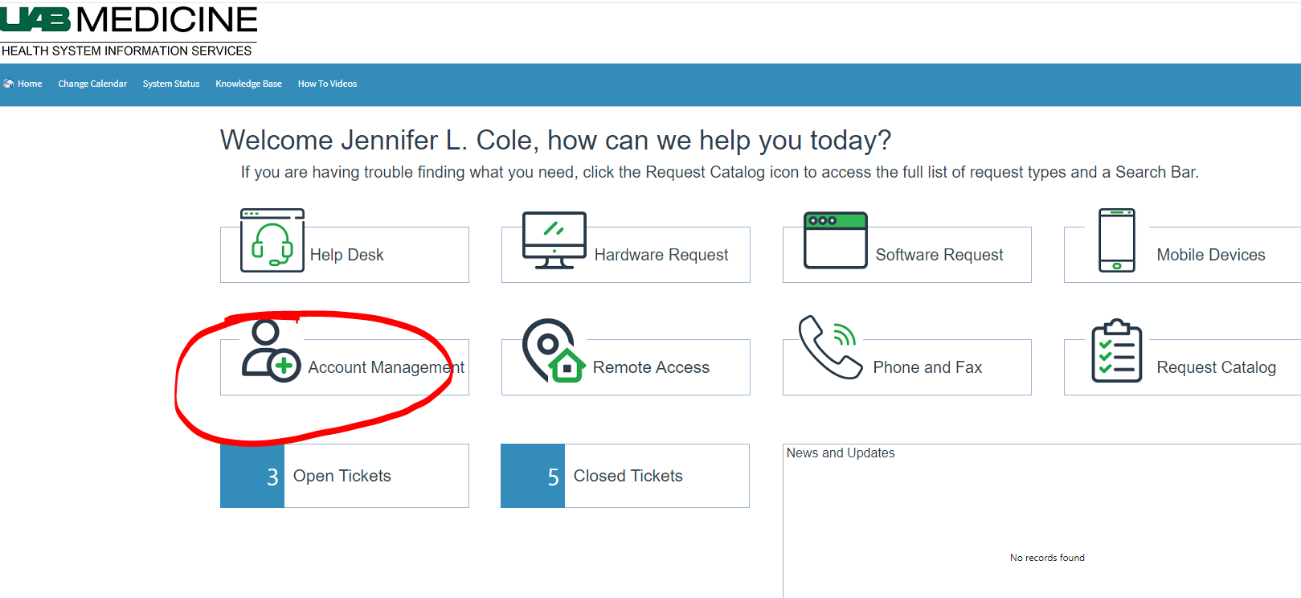
- Choose ‘Extend Vendor Access’

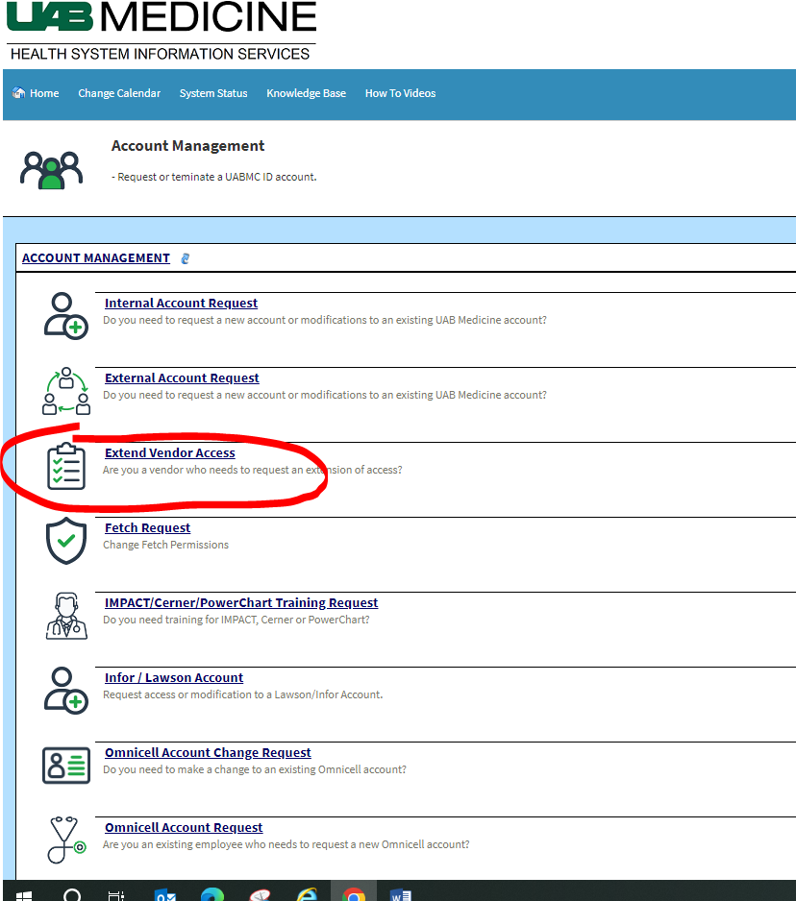

- Complete the form and click submit.

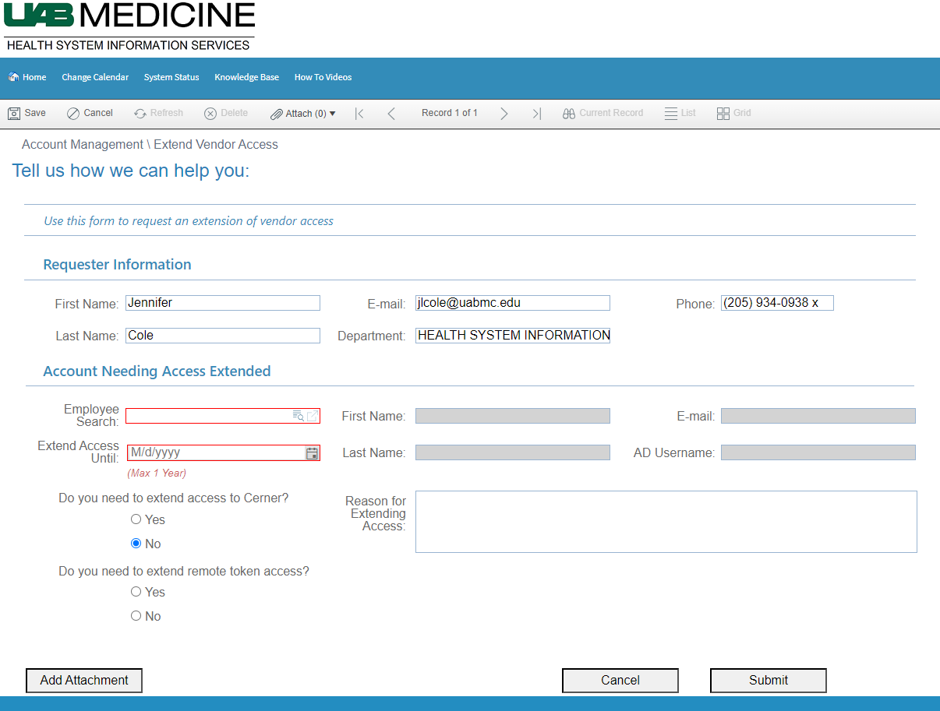

IMPORTANT: If system access is no longer needed for a research monitor please notify the HSIS Support Desk immediately so the account can be disabled.

Password Resets or Other Issues
- If a password reset is needed or other issues encountered the monitor should contact the HSIS Support Desk at 205-934-8888.

