Kyocera Instructions printed March 21, 2019
General background | This multi-function machine is called a Kyocera. (That is the manufacturer’s name)  It is provided and serviced by a company in Birmingham called Ameritek.
Login is much easier | It will recognize you via your UAB ID badge (aka BlazerID card, aka One Card)  The first time you use any of the Kyoceras:  - swipe your badge at the front of the Kyocera (near the red light)  - then type in your DOPM username and password.  - Then your badge again.  After that, each time all you have to do to login, is “Swipe in” – which is great !!  ~or~  Alternatively, if you don’t have your badge with you, you can just type in your DOPM username and password.
Trouble or Training | If anyone has any trouble, or wants individual training:  - Contact dopmHelp (dopmHelp@uabmc.edu) – usually Lisa but others can help too  - Or Valerie Winston  - Also other folks can probably help you too.
First Screen you see after swiping in. | You have 3 choices  - Print Release – this is where you release print jobs you sent to actually print.  - Device Functions – which is where you fax, copy and scan to other places.  - Scan—to your email address or your H:Drive.  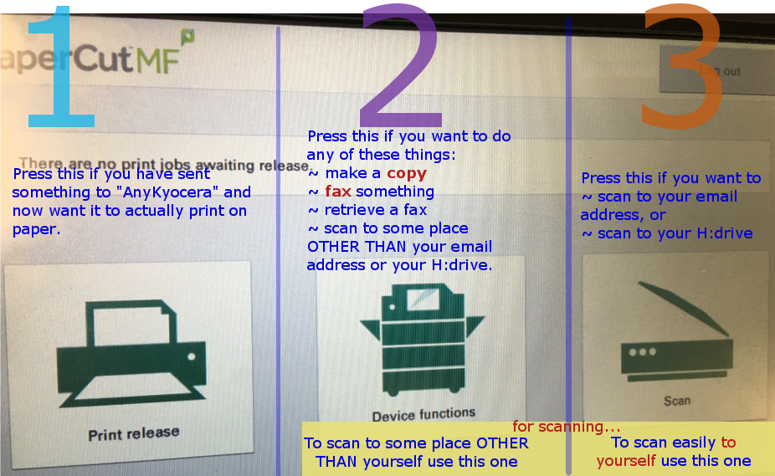  Read on for more details about each of these 3.
Fax # | The fax number here (room ______ ) =  (Also see next page for other fax numbers  and how to get to incoming faxes.)
To Logout | 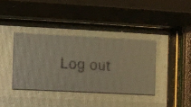 or 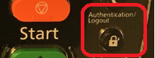 or use your badge to “swipe out”
The following is about Print Release (1)
If you want to print | At your computer, choose to print to “AnyKyocera”.  That means you can retrieve your print job from any Kyocera in Medical Towers.
How long do I have to print? | If you don’t Print Release within 4 hours, it will automatically delete, and there’s no charge.
Can I force it to go ahead and just print now? | If you’re thinking:  “But I don’t want to actually be standing by the Kyocera for it to print” … or ….  “I want someone other than myself to be able to pick up a job I printed”…  Sorry, but that is not allowed.
The following is about Device Functions (2)
Then... you will have to choose an account.
Basic copies | If all you want is basic black and white copy(s) simply press the big green [Start] button.
Black vs color  (Defaults) | The default for copies is black.  The default for scanning is color.  But you have other options as needed.
Scan… fax | There's multiple ways to do things, but the easiest is:  If you want something other than basic black and white copy(s)…. use these 6 plastic buttons to say what you want:  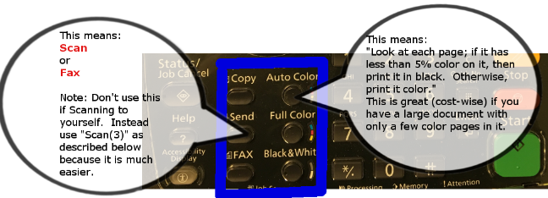
Scanning | Options:  - If you regularly scan someplace, a “one touch” button can be set up for that.  - Just send that request to us (dopmHelp@uabmc.edu)  - Otherwise, you can type in the email address  - Or use “Scan(3)” (as described below) to scan to yourself; and then forward (via your computer) to whomever needs it.
Faxing | If you regularly fax someplace, a “one touch” button can be set up for that  - Just send that request to us (dopmHelp@uabmc.edu)  For example, an Optidoc button is already set up to allow easy faxing.  If on campus (just like with phones), you just need a 5-digit fax number.  If off-campus, dial 9 first, and then the number, just like if dialing a phone number.
Fax Numbers | MT-111 = 975-9395 MT-502H = 934-0777 MT-505 (Biz Office Lobby) = 996-1549 MT-516 = 934-0455 MT-753 = 934-8028 MT-601 = 934-7959 MT 621 = 975-5153
Fax Receiving | Faxes don’t automatically print out…. HIPAA compliant  To get to FAX box:  - [Device Function]  - Choose an account  - Home (plastic button)  - [FAX Box]….. [Open]  - [Preview] or [Detail] or [Print]  - “FAX box” shows all faxes received.  - You can see a thumb nail of any fax that’s come in.  - We have to rely on each other to notify people, especially people who might not check regularly.
Stuck in the Device Functions screen. | 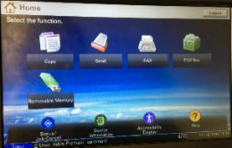  If you find yourself stuck here  ….but want to do something other than these options (such as easily scan to yourself), then you simply need to [logoff] and swipe in again.  There is no way around it; neither of the “Home” buttons helps
The following is about Scan (3) …this scans to YOU
Then... you will have to choose an account. (But there’s no actual cost for it.)
If you don’t see an account listed for what you’re scanning, select “Copier Fund”
Scanning | 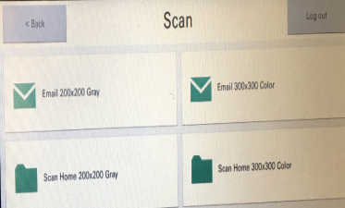  You have two choices:  - Scan Home, which puts it in a folder called “Scans” on your H:Drive.  (If this folder doesn’t already exists, it’ll automatically be created.)  - Or Email – which scans to the email address we have for you.  Notes:  - The numbers beside the options indicate the quality of scan: higher numbers create crisper images but larger file size.  - Generally large documents should not be scanned to Email. Instead, they should go to Scan Home instead, to avoid errors and to avoid clogging up the email system.
Scanning to someone other than yourself. | If you want to scan to someone other than you:  - Simply use this to scan to yourself and; then forward using email at your computer.  - Or see the “Device Functions(2)” section above.
Other helpful info
Adding Accounts | If you need a new accounting “charge to” account added to the account list that is not there now (for copies, printing), please contact Valerie Winston in the business office.
“Program Keys” for stuff you do regularly | We (dopmHelp) can set up “Program Keys” for stuff you do regularly. Examples:  - call it “Bobs jobs” to customize what Bob normally uses – Tiff, color, stapled and hole punched  - Set up 1 touch button to scan to 5 specific people at the same time
Account order in list | ~At the Kyocera: The Kyocera remembers the last 15 accounts used by you and puts them on top, so you mostly shouldn’t have to scroll through all the accounts.  ~At your computer when printing: It just remembers the last one you used.
Hole punch | The punch goes on the leading edge, so if want it at top for medical records for example, feed it through Kyocera landscape, not portrait.
Lots of options | Kyoceras will do many things. Feel free to explore all the options and experiment.  If you find something amazing that should be shared, let us (dopmHelp) know.
These instructions | If we’ve missed anything in this or you see any errors contact Lisa at dopmHelp@uabmc.edu.  These instructions are also available on the DOPM HelpPages: http://help.dopm.uab.edu
Problems, not working, jamming, etc | If any problems, please contact us (dopmHelp) at  - dopmHelp@uabmc.edu or  - call 934-7662.

